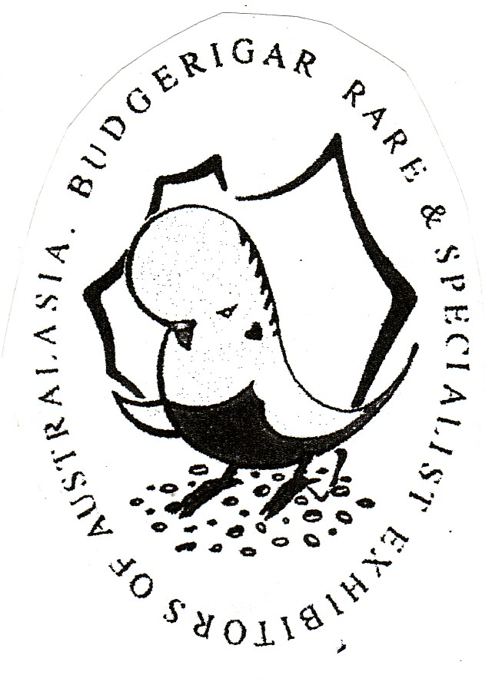
B.S.S.A. Ron Norman
69th Annual Show 2017
In conjunction with
“BRASEA” State Show

Saturday 10th June 2017
Vermont Uniting Church Hall
Corner of Cross Road & New Street
SOUTH PLYMPTON

This Show will be an ‘OPEN SHOW’
Any member financial with BSSA or any other Bird Society may show. THIS IS A STATUS MOVEMENT SHOW

TROPHY PRESENTATION AT 2.00 PM

Postal entries close with the Show Manager Wayne Weidenhofer on Friday 2nd June, 2017
86 Mentone Road, VICTOR HARBOR SA 5211
Email and phone entries will be accepted up to Sunday 4th June, 2017. No late entries will be accepted.

All inquiries to be directed to the Show Manager Wayne Weidenhofer on Ph 85 524283 or Email address:- wayneweedo@tpg.com.au

Entry Fee : $1.00 per bird for the first 20 entered or the maximum of $20-00. Any further birds are at no charge but a donation may be given.

Exhibitors to mark entries “I”, “N” or “J” depending on status.

Postal entry Option 1: Entry fee to accompany the entry form with a stamped self addressed envelope and cheque or money order payable to the BSSA.
Postal entry Option 2: Send stamped self addressed envelope with entry form and pay on the day.
Email Option: Email electronic version of the entry form and pay on the day, but adding additional $1.50 for postage and handling.

PRIORITY MAIL NOW 4 DAYS WITH STANDARD MAIL NOW UP TO 6 DAYS.

BIRDS to be benched between 8-30 and 9-15 am Saturday 10th June, 2017.

Four birds shall constitute a class. The Show Committee shall reserve the right to combine classes

All exhibits to be presented in Standard Show Cages as approved by the ANBC.

The Safety Officer has the right to reject entries prior to judging for signs of illness, deformity or poorly prepared Show Cages that are deemed hazardous or unhealthy to all the birds. Birds are exhibited at the risk of the owner but the Show Committee will exercise all due care.

Cages to be fitted with a White D drinker ½ full with seed in it. On the bottom wire fixed near the door.
White paper or plastic insert on floor of cage. Equal parts Canary, Jap and White Millet are the only seed permitted. Each cage to be fitted with a drinker (dry) with the position being four spaces in level with the perch.

Stickers are to be placed on the bottom left hand side of the Show Cage. Hot Weather Policy applies.

RON NORMAN ANNUAL SHOW TROPHY LIST

Trophy, Sash and Diploma

GRAND CHAMPION
Reserve Champion Cock - Reserve Champion Hen
Third Champion Cock - Third Champion Hen
Fourth Champion Cock - Fourth Champion Hen

CHAMPION INTERMEDIATE

Reserve Intermediate Cock - Reserve Intermediate Hen

CHAMPION NOVICE

Reserve Novice Cock - Reserve Novice Hen

Most accumulated points (NOVICE) Sponsored by Yankalilla Seeds/Nature’s Harvest

BEST JUNIOR EXHIBIT

BEST OF VARIETY – Gold Breeders Award

Best Normal Green Series Best Spangle D/F
Best Normal Grey Green Best Opaline Best Normal Blue Series Best Opaline AOSV
Best Normal Grey Best Normal Spangle
Best Normal Yellow Faced Blue Best Spangle ASOV
Best Dilute Best Dominant Pied
Best Lutino Best A.O.V.
Best Albino Best Yellow Faced AOSV.
Best Cinnamonwing

RON NORMAN STATE (BRASEA) SHOW TROPHY LIST

BEST OF VARIETY – BRASEA Trophies & Diploma

Best Blackeye Self Best Fallow
Best Lacewing Best Crested
Best Clearbody Best Clearwing

Rosette & Diploma

Best Normal Visual Violet Best Normal Golden Faced Blue
Best Greywing Best Danish Recessive Pied

