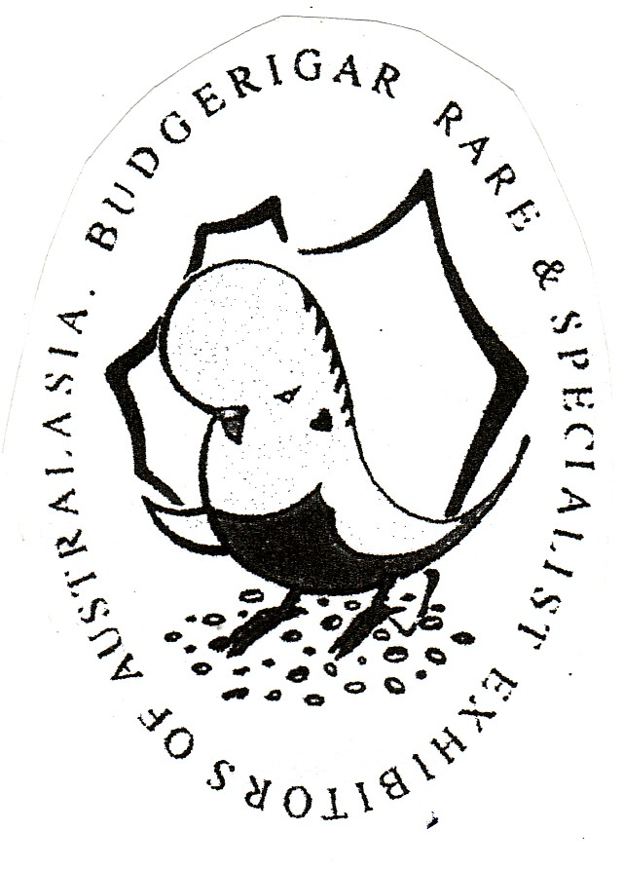
B.S.S.A. Ron Norman 72nd Annual Show 2021
In conjunction with “BRASEA” State Show

Saturday 12th June 2021

Vermont Uniting Church Hall
Corner of Cross Road & New Street
SOUTH PLYMPTON

This Show will be an ‘OPEN SHOW’
Any member financial with BSSA or any other Bird Society may show.

THIS IS A STATUS MOVEMENT SHOW

BIRDS NEED TO BE SPOTTED FOR THIS SHOW

Postal entries close with the Show Manager Wayne Weidenhofer at 86 Mentone Road, VICTOR HARBOR SA 5211 on Friday, 4th June, 2021. Mobile/Landline entries (0435 032 125/85 524283, email entries (wayneweedo@tpg.com.au) and or Messenger entries close on Saturday, 5th June, 2021.

Entry Fee : $1.00 per bird for the first 20 entered with payment for entries and postage to be made on show day.

Exhibitors to mark entries “I”, “N” or “J” depending on status.

EXHIBITORS WITH 15 BIRDS OR MORE AND TRAVELLING 50 KILOMETRES OR MORE TO THE SHOW VENUE WILL BE COMPENSATED $25.00.

NO LATE ENTRIES PLEASE. BE AWARE THAT PRIORITY MAIL IS NO LONGER AVAILABLE. A SECOND SET OF CAGE STICKERS WILL BE AVAILABLE SATURDAY MORNING IF THEY DON’T ARRIVE.

BIRDS to be benched from 8.30 a.m. with Judging commencing at 9.30 a.m.

All exhibits to be presented in a standard Show Cages as approved by the ANBC.

BSSA WILL ACCEPT CHROME OR POWDER COATED SHOW CAGES IN THIS SHOW.

All exhibits must have a closed ANBC ring except Classes 61 and 62.
No double or split rings as this constitutes a marked bird

B.S.S.A. Ron Norman 72nd Annual Show 2021
In conjunction with “BRASEA” State Show

BIRDS MAY NOT BE REMOVED BEFORE TROPHY PRESENTATION AT 2.00 PM

LUNCH IS PROVIDED

The Safety Officer has the right to reject entries prior to judging for signs of illness, deformity or poorly prepared Show Cages which are deemed hazardous or unhealthy to all the birds.

Birds are exhibited at the risk of the owner but the Show Committee will exercise all due care.

Cages to be fitted with a White D drinker ½ full with seed and fitted on the bottom wire near the door. White paper or plastic insert maybe used on the cage floor.
Equal parts Canary, Jap and White Millet are the only seeds permitted. Each cage to be fitted with a drinker (dry) with the position being four spaces in level with the perch. Stickers to be placed on the bottom left hand side of the Show Cage.

Four birds shall constitute a class. The Show Committee shall reserve the right to combine classes.

Hot Weather Policy:- In the event of the temperature being forecast 32c or above on the night before the Show (Channel 7 6.00 p.m. News) the Show will be cancelled. It will be the responsibility of the exhibitor to check the weather forecast.

NO BUDGIE BASH BY TENDER OR SALE DUE TO COVID AND HALL RESTRICTIONS. A BSSA COVID SAFETY PLAN AND A QR CODE WILL BE OPERATING WITH COVID MARSHALLS PRESENT.

OFFICIALS AND EXHIBITORS ARE THE ONLY PEOPLE ALLOW ON CHURCH PREMISES DUE TO A COVID HALL DIRECTIVE.

RON NORMAN ANNUAL SHOW 2021 - TROPHY LIST

MAJOR SPONSORS:- AVIAN VITALITY, YANKALILLA SEEDS/NATURE’S HARVEST, BRASEA AND ELENBEE BIRD SEEDS AND SUPPLIES

Total prize money $750.00

GRAND CHAMPION Trophy - $50.00 - Diploma
(AVIAN VITALITY VOUCHER)

RESERVE CHAMPION COCK Trophy - $20.00 – Diploma
RESERVE CHAMPION HEN Trophy - $20.00 - Diploma
THIRD CHAMPION COCK Trophy - $20.00 - Diploma
THIRD CHAMPION HEN Trophy - $20.00 - Diploma
FOURTH CHAMPION COCK Trophy - $20.00 - Diploma
FOURTH CHAMPION HEN Trophy - $20.00 - Diploma

RON NORMAN ANNUAL SHOW 2021 - TROPHY LIST

CHAMPION INTERMEDIATE Trophy - $20.00 – Diploma
(AVIAN VITALITY VOUCHER) 10KG Premium Budgie Mix
Sponsored by Yankalilla Seeds/Nature’s Harvest

RESERVE INTERMEDIATE COCK Trophy - $10.00 – Diploma
RESERVE INTERMEDIATE HEN Trophy - $10.00 – Diploma

CHAMPION NOVICE Trophy - $20.00 – Diploma
(AVIAN VITALITY VOUCHER) 10KG Premium Budgie Mix
Sponsored by Yankalilla Seeds/Nature’s Harvest

RESERVE NOVICE COCK Trophy - $10.00 – Diploma
RESERVE NOVICE HEN Trophy - $10.00 – Diploma

NOVICE AWARD Most accumulated points - 20KG Premium Budgie Mix
Sponsored by Yankalilla Seeds/Nature’s Harvest

BEST JUNIOR EXHIBIT Trophy - $10.00 – Diploma

BEST BUSH/PET BUDGERIGAR Rosette - Diploma

THIS IS A BRASEA CLEARWING CHALLENGE AND A GOLDEN CREST AWARD EVENT.

BEST OF VARIETY – Gold Breeders Award

30 Class winners receive $15.00 prize money

Best Normal Green Series Best Cinnamonwing
Best Normal Grey Green Best Spangle D/F
Best Normal Blue Series Best Opaline
Best Normal Grey Best Opaline AOSV
Best Normal Yellow Faced Blue Best Normal Spangle
Best Dilute Best Spangle AOSV
Best Lutino Best Dominant Pied
Best Albino Best Australian White Cap
Best Dk Eyed Clear Best AOSV/NSV

RON NORMAN STATE (BRASEA) SHOW 2021 - TROPHY LIST

BEST OF VARIETY – BRASEA Trophies/Rosette & Diploma

Best Normal Visual Violet Best Yellow Faced AOSV
Best Clearwing Best Greywing
Best Recessive Pied Best Crested

Best Blackeye Self Best Fallow
Best Lacewing Best Clearbody
Best Aust Golden Faced Blue Best Rainbow

